1 Which pair contains both scalar quantity?
A displacement : acceleration
B force : kinetic energy
C momentum : velocity
D power : speed

2 Which of the following could be measured in the same units as torque?
A mass / acceleration
B mass x acceleration x distance
C force / distance
D force x acceleration

3 The notation ns is used as an abbreviation for a certain unit of time.
What is the name and value of this unit?

 | Name | Value
A | Microsecond | 10⁻⁶
B | Microsecond | 10⁻⁹
C | Nanosecond | 10⁻⁶
D | Nanosecond | 10⁻⁹

4 A thermometer has a smallest division of 1°C. This thermometer is used to measure temperature rise in pure water from 25 °C to boiling.
What is the percentage uncertainty in the measurement of the temperature rise?

A 0.5 % B 0.8 % C 1.3 % D 1.7%

5 The time-base on a cathode-ray oscilloscope is set at 7 ms / cm. A trace consisting of two pulses is recorded as shown in the diagram.

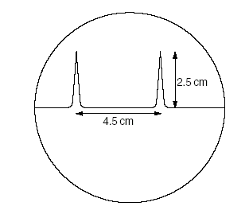
What is the time interval between the two pulses?

A 17.5 ms B 14.0 ms C 31.5 ms D 49.0 ms

6 A micrometer screw gauge is used to measure the diameter of a copper wire. The reading with the wire in position is shown in diagram 1. The wire is removed and the jaws of the micrometer are closed. The new reading is shown in diagram 2.

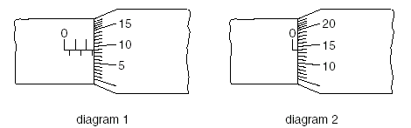

What is the radius of the wire?
A 1.23 mm B 1.225 mm
C 1.36 mm D 1.360 mm

7 A car at rest in a traffic queue moves forward in a straight line and then comes to rest again. The graph shows the variation with time of its displacement.

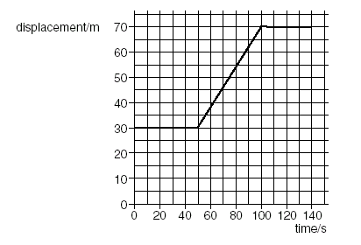
What is the total distance traveled by the car?
A 6.8 m B 40 m C 6.8 km D 40 km

8 Which diagram correctly shows the addition of a 4N and a 3N force?
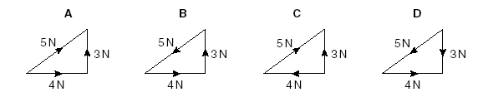

9 An object is projected vertically upwards. Assuming air resistance is negligible, the acceleration of the object from the time it is projected until it returns to the ground can be correctly illustrated by the graph
g

0
a/ms⁻²
t/s
a/ms⁻²
g
t/s
A B

C D
g

0
-g
a/ms⁻²
t/s
g

0

a/ms⁻²
t/s

10 A load is to be moved using a wheelbarrow. The total mass of the load and wheelbarrow is 60 kg. Assume the weight of the wheelbarrow and load acts through the same point. (Take g=10 ms⁻²)
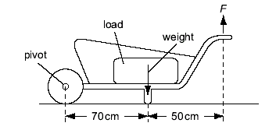

What is the size of force F needed just to lift the loaded wheelbarrow?

A 350 N B 430 N C 600 N D 840 N

11 What is the expression used to define power?

A input energy / output energy
B energy x time taken
C force x velocity
D work done / time taken

12 A spring extends by 4 cm when 10 N is suspended from it. Two of these springs are used as shown to carry a 30 N load.
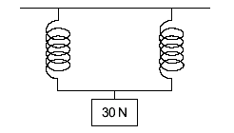
What is the extension of each spring?

A 4 cm B 6 cm C 8 cm D 12 cm

13 The diagram shows the energy transfer through a machine.

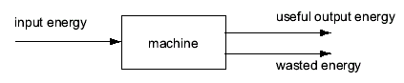
The machine is 50 % efficient.
Which is correct?

A input energy = useful output energy
B useful output energy = input energy + wasted energy
C wasted energy = input energy + useful output energy
D wasted energy = useful output energy

- Which is not one of Newton’s law of motion?

A The total momentum of a system of interacting bodies remains constant, providing no external force acts.
B The rate of change of momentum of a body is directly proportional to the external force acting on the body and takes place in the direction of the force.
C If body A exerts a force on body B, then body B exerts an equal and oppositely-directed force on body A.
D A body continues in a state of rest or of uniform motion in a straight line unless acted upon by some resultant external force.

15 A small car of mass 800 kg, is being driven in foggy condition. In this situation the maximum deceleration of the car is 7.5 ms⁻². While driving at the constant speed of 21 ms⁻¹, the driver sees a stationary car 30 m ahead and takes 0.40 s to react. Determine the speed at which the car will hit the stationary car.

A 3.0 ms⁻¹ B 5.2 ms⁻¹ C 10.8 ms⁻¹ D 12.3 ms⁻¹
16 X and Y are lamps with filaments made from the same material. The filament of lamp X is thicker and shorter than that of lamp Y. When connected to the mains and switched on, which is the brighter lamp and which lamp has the larger resistance?

 | brighter lamp | larger resistance
A | X | X
B | X | Y
C | Y | X
D | Y | Y

17 A uniform beam of weight 100 N is 5.0 m long and is supported on a pivot situated 2.0 m from one end. When a load of weight W is hung from that end, the beam is in equilibrium, as shown in the diagram.

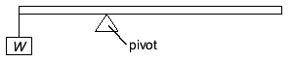

What is the value of W ?
A 25 N B 35 N C 75 N D 100 N

18 A girl uses paper-clips to balance a toy bird on her finger as shown.
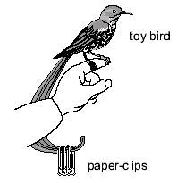
What is the effect of the paper-clips?

A They help to raise the centre of mass above her finger.
B They help to raise the centre of mass to her finger.
C They help to lower the centre of mass below her finger.
D They do not affect the centre of mass but increase the weight.

19 Which of the statement below explains the presence of pressure in a container?
A Colusions between air molecules in the container.
B Colusions between air molecules in the container and container`s walls.
C Rate of change of momentum between molecules during collisions.
D Rate of change of momentum between molecules and container’s wall during collisions.

- Young’s double slit interferometer is illuminated with green light of wavelength 546 nm. The double slits are 0.100 mm apart and the screen is 20.0 cm away from the double slits. What is the distance on the screen, between the two consecutive bright fringes?

A 1.09 mm B 4.36 mm C 6.00 mm D 1.09 cm

- Which one of the following groups of electromagnetic waves is in the descending order of wavelength?

A Gamma rays, ultra-violet, radio-waves
B Gamma rays, visible light, ultra-violet
C Microwaves, ultra-violet, X-rays
D Visible light, infra-red, X-rays.

- S₁ and S₂ are loudspeakers facing each other and emitting continuous sound waves of frequency 1100 Hz. M is a small microphone, which runs on straight track between S₁ and S₂ at a speed of 30 m s⁻¹. The velocity of sound is 330 ms⁻¹. The sound received by M will fluctuate with a frequency of

A 100 Hz B 200 Hz C 400 Hz D 800 Hz

23 A wave with a frequency of 3.0 x 10¹⁴ Hz passes through a point. What is the number of wavelength that passes through that point in a second?

A 3.0 x 10¹⁴
B 0.3 x 10 ⁻¹⁴
C 1.0 x 10⁻⁶
D 1.0 x 10⁶

24 Which one of the following statements correctly describes the relationship between two consecutive antinodes in a standing wave?

A Their oscillations are in phase with each other.
B Both will pass their equilibrium positions with opposite velocities.
C When one has maximum kinetic energy, the other antinode has maximum
potential energy.
D Both have minimum energy since the amplitude of oscillations is minimum.

- A point source of sound emits energy equally in all directions at a constant rate and a person 6 m from the source listens. After a while, the intensity of the source is halved. If the person wishes the sound to seem as loud as before, how far should he be now from the source?

A  m B 2 m C 3 m D 4 m

- Progressive waves of frequency 400 Hz are superimposed to produce a system of stationary waves in which adjacent nodes are 1.5 m apart. What is the speed of the progressive waves in ms⁻¹?

A 200 B 400 C 800 D 1200

27 In an experiment to demonstrate Brownian motion, smoke particles in a container are illuminated by a strong light source and observed through a microscope. The particles are seen as small specks of light that are in random motion.
What causes this motion?

A collisions between the smoke particles and the walls of the container
B collisions between the smoke particles and air molecules
C convection currents within the air as it is warmed by the light source
D Kinetic energy gained by the smoke particles on absorption of light

28 A wire of Young’s modulus E is subjected to a stretching stress, σ. What is the elastic potential energy stored per unit volume of the wire?

A 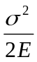 B 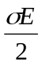 C 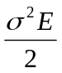 D 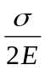

29 Which of the following statements about glass is wrong?

A Glass does not melt at a fixed temperature because all its bonds do not break at the same temperature.
B Glass is very viscous when melted, so that upon freezing the molecules cannot arrange themselves in an orderly, regular pattern.
C Glass consists of long molecular chains interlinked together such that as the temperature is raised, the chains uncoil and attempt to straighten.
D The intermolecular forces are such that glass is stiff but not strong.
30 A resonance tube open at both ends and responding to a tuning fork
A always has a central node.
B always has a central antinode.
C always has an odd number of nodes.
D always has an odd number of nodes + antinodes.

31 In the direction indicated by an electric field line,

A the electric field strength must increase
B the electric field strength must decrease
C the potential must increase
D the potential must decrease

32 The diagrams show four different ways in which currents I₁, I₂, I₃ and I₄ can combine at a junction. For which of these junctions is the following equation correct? I₁ + I₂ = I₃ + I₄

A B
I₁
I₂
I₃
I₄
I₃
I₂
I₁
I₄

I₁
I₂
I₃
I₄
I₂
C D
I₄
I₁
I₃

33 Which statement describes the electrical potential difference between two points in a wire carrying a current?

A the force required to move a unit positive charge between the points
B the ratio of the energy dissipated between the points to the current
C the ratio of the power dissipated between the points to the current
D the ratio of the power dissipated between the points to the charge moved

- A cell is connected in series with a 4 Ω resistor and a switch as shown in the figure below. A voltmeter connected across the cell reads 12 V when the switch is open but 8 V when it is closed.

V

4 Ω

What is the internal resistance of the battery?
A 1 Ω B 2 Ω C 3 Ω D 4 Ω

35 An electric cable of resistance 0.80 per kilometer length of cable conveys a current of 25 A. If the electric potential at a point on the cable is 250 V, what is the electric potential at another point a distance of 5 km from the point in the direction of the current?

A 120 V B 150 V C 180 V D 210 V

- The resistance of a certain circuit element is directly proportional to the current passing through it. When the current is 1.0 A the power dissipated in the element is 6.0 W. What is the power dissipated when the current is raised to 2.0 A?

A 6.0 W B 12 W C 24 W D 48 W

- A generator produces 100 kW of power at a potential difference of 10 kV. The power is transmitted through cables of total resistance 5 . What is the power loss in the cables?

A 50 W B 250 W C 500 W D 1 000 W

38 One reaction which might be used for controlled nuclear fusion is shown.
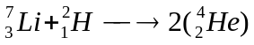+ X
Which is particle X?

A an -particle B an electron C a neutron D a proton

39 A naturally occurring isotope of radium, 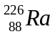, has a half-life of 1622 years. Its radioactive decay may be represented by the equation
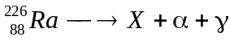
Where X is a daughter nuclide, α is an alpha-particle and γ is a gamma ray, the proton number of X is

A 86 B 88 C 222 D 224

- The deviation of -particles by thin metal foils through angles that range from 0⁰ to 180⁰ can be explained by

A scattering from free electrons.
B scattering from bound electrons.
C diffuse reflections from the metals surface.
D scattering from small but heavy regions of positive charge.

